Airport Authority Analysis
Report

Name: Vedashree Laxmivilas Joshi
Internship project: Role: Power Bi intern
Organization name: Atos prayas foundation
1. Abstract

This project presents a comprehensive data analysis and visualization solution developed for the Airport Authority using Power BI. The primary aim was to uncover operational patterns, identify inefficiencies, and support data-driven decision-making in areas such as passenger management, flight operations, and resource allocation. The analysis involved integrating multiple datasets, cleaning and transforming raw data, and developing interactive dashboards that provide intuitive insights. The study revealed significant trends in passenger behaviour, flight delays, peak operational hours, and bottlenecks in resource distribution. These insights enabled the Airport Authority to better allocate manpower, streamline operations, and enhance passengers’ experience. The Power BI dashboard built during this project serves as a real-time monitoring tool and an analytical framework that supports both operational and strategic planning. By analysing historical and real-time data, the project introduces a robust approach to improving airport efficiency, reducing delays, and ensuring optimal use of facilities. Ultimately, this project demonstrates the impact of BI tools on modern transportation systems, illustrating how visual analytics can transform unstructured airport data into actionable intelligence.

2. Introduction

Airports today operate in an environment characterized by high passenger volumes, tight schedules, and complex logistical operations. With the increasing globalization of air travel, airports must operate with precision, reliability, and efficiency. Traditional methods of manual data tracking are no longer adequate to meet these demands. This project was initiated to bridge the gap between operational complexity and effective data utilization by employing Power BI as an analytical and visualization platform. Power BI's ability to integrate large datasets, perform advanced data modelling, and generate dynamic visual reports makes it ideal for airport operations analysis. The project focused on creating a structured analytical system that helps the Airport Authority gain a deeper understanding of trends related to passenger movement, flight operations, and resource usage. By transforming raw operational data into meaningful visualizations, this project aimed to empower airport managers with timely insights that support planning, forecasting, and day-to-day decision-making. This initiative represents the growing need for digital transformation in aviation, emphasizing how modern BI tools can enhance operational outcomes and customer satisfaction within critical public infrastructure.

3. Problem Statement

The Airport Authority lacked a centralized analytical system capable of providing real-time insights into airport operations. Passenger traffic continues to grow every year, making it increasingly difficult for airport administrators to anticipate peak hours, allocate staff efficiently, and minimize wait times. Similarly, flight operations involve numerous dependencies—weather conditions, airspace congestion, maintenance issues—all of which require detailed analysis to minimize delays and cancellations. The absence of data-driven insights led to inefficiencies such as understaffed terminals during peak hours, overutilized resources, and operational uncertainties. Furthermore, data was scattered across multiple platforms, making manual reporting slow, inconsistent, and error-prone. Without an integrated BI solution, the Airport Authority was unable to identify patterns in flight delays, track real-time performance metrics, or monitor passenger flow effectively. This project aimed to address these challenges by developing a comprehensive Power BI dashboard that consolidates data from multiple sources and provides a unified, interactive view of airport performance metrics.

4. Objectives of the Project

The primary objectives of this project were designed to enable data-driven optimization of airport operations. The first objective was to create a visually appealing and fully interactive Power BI dashboard that provides administrators with clear insights into key performance indicators such as flight operations, passenger flow, and resource usage. Another objective was to analyze historical trends in passenger traffic and flight delays to identify peak travel periods and reoccurring operational challenges. Through this analysis, the project aimed to uncover operational inefficiencies and propose specific, actionable recommendations for improvement. Additional objectives included detecting long-term patterns across flight schedules, identifying weather-related impacts on operational performance, and integrating real-time monitoring capabilities. Overall, the project aimed to establish a strong analytical foundation that supports informed decision-making and strategic planning within the airport ecosystem.

5. Scope of Work

The scope of this project encompasses data acquisition, cleaning, transformation, visualization, and in-depth analysis of airport-related datasets. It includes evaluating multiple dimensions of airport operations such as passenger behaviour, flight delays, cancellations, terminal congestion, and staff allocation. The project is limited to analysing historical and near-real-time data available from the Airport Authority’s internal systems and external data sources like public aviation logs. The scope also includes the development of dashboards, reports, and KPIs that allow airport officials to monitor metrics efficiently. However, it does not cover the implementation of operational changes or integration with airport hardware systems such as sensors or boarding gates. The project focuses solely on data analytics, modelling, and visualization, laying a foundation for further enhancements such as predictive analytics or machine learning integration.

6. Methodology

The methodology followed in this project was systematic and structured to ensure accuracy, clarity, and usability of insights. The process began with data collection, where raw data was gathered from airport databases, passenger logs, flight records, and external aviation sources. This was followed by data cleaning, which involved removing duplicate records, correcting inconsistencies, and addressing missing values. Next, data transformation techniques were applied to structure datasets in a format compatible with Power BI’s data modelling framework. After preparation, data analysis was conducted using Power BI’s built-in functions to identify trends and correlations. The next step involved dashboard development, creating interactive visualizations including maps, time-series charts, tree maps, KPIs, and slicers. Finally, the insights were validated with real-world operational scenarios to ensure their relevance and accuracy. This methodological approach ensured that the final dashboard was both functional and meaningful to decision-makers.

7. Tools & Technologies Used

The project utilized a combination of analytical and data management tools. Power BI served as the core visualization and analysis platform due to its robust data modelling environment, DAX capabilities, and dynamic dashboard features. Microsoft Excel was used for initial dataset assessment and manual cleaning processes, especially for verifying data formats and identifying anomalies. SQL played a crucial role in generating filtered datasets, executing joins, and extracting relevant fields from large operational databases. Python was employed for advanced preprocessing, generating statistical summaries, and handling data-heavy transformations that required automation. Collectively, these tools formed a complete analytical ecosystem that supported efficient, scalable, and accurate data insights.

8. Data Description

The dataset used for this project consisted of multiple data categories relevant to airport operations. Passenger data included demographics, travel frequency, peak-hour entries, terminal footfall, and origin-destination patterns. Flight data comprised scheduling details, delays, cancellations, aircraft types, gate assignments, and turnaround times. Operational data included staff allocation schedules, available airport resources, counters, runway usage, and on-ground vehicle availability. The dataset varied in quality—some fields were incomplete, while others required normalization. Data volume ranged from a few thousand to several hundred thousand records, depending on the operational variable. The diversity of data types required careful cleaning and transformation before integration into Power BI.

9. Implementation Steps

The implementation was carried out in several structured phases. The first step involved data acquisition, where datasets were extracted from various internal and external sources. This was followed by data cleaning and transformation, ensuring that all data fields were consistent, accurate, and analysis-ready. During this phase, missing values were imputed, outliers were addressed, and categorical fields were standardized. The third step was data modelling, where relationships were established among datasets to support meaningful insights. The fourth step involved dashboard development, including designing KPIs, reports, charts, and navigation features. The final stage involved analysis execution, where insights were interpreted, patterns were documented, and recommendations were formulated based on observed trends.

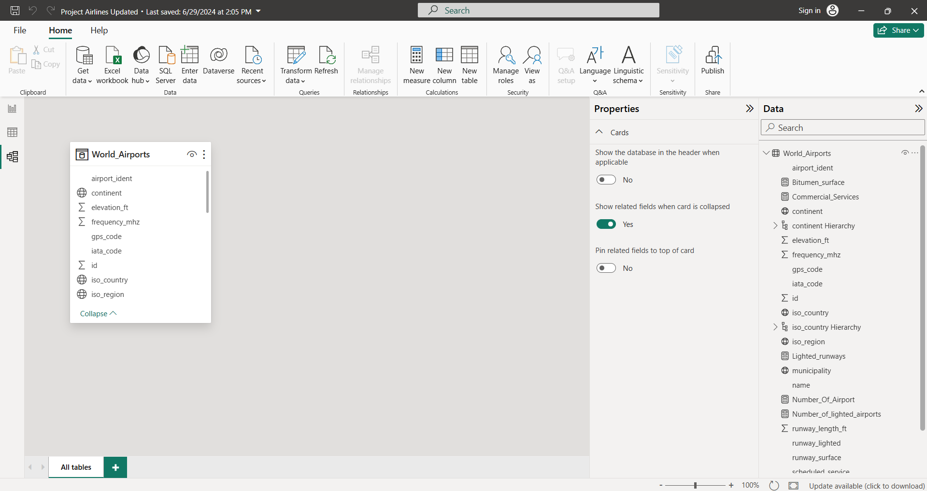

10. Analysis & Findings

The analytical results revealed key insights into airport operations. Passenger analysis indicated clear peak hours during early mornings and late evenings, with significant variations between weekdays and weekends. Demographic data showed increasing travel among younger age groups, impacting terminal service needs. Flight analysis identified recurring delay patterns associated with weather conditions and specific airlines. Turnaround times varied significantly across aircraft types, identifying opportunities for operational optimization. Resource analysis revealed imbalances in staff allocation—overstaffing during low-traffic periods and understaffing during peak hours. These findings collectively provided actionable insights that could be used to enhance operational efficiency, reduce delays, and improve passenger satisfaction.

11. Results & Output

The primary deliverable of the project was a fully functional Power BI dashboard that consolidated all key operational metrics into an intuitive and interactive interface. This dashboard allowed real-time monitoring of passenger traffic, flight delays, and resource usage across terminals. Airport officials gained improved visibility into operational bottlenecks, enabling proactive decision-making. The dashboard’s drill-down features allowed deeper exploration of trends, helping identify the root causes of delays and inefficiencies. Additionally, custom KPIs provided quantifiable metrics for evaluating performance and tracking improvements over time. Overall, the project successfully delivered a data-driven framework that significantly enhanced the Airport Authority’s operational transparency and decision-making agility.

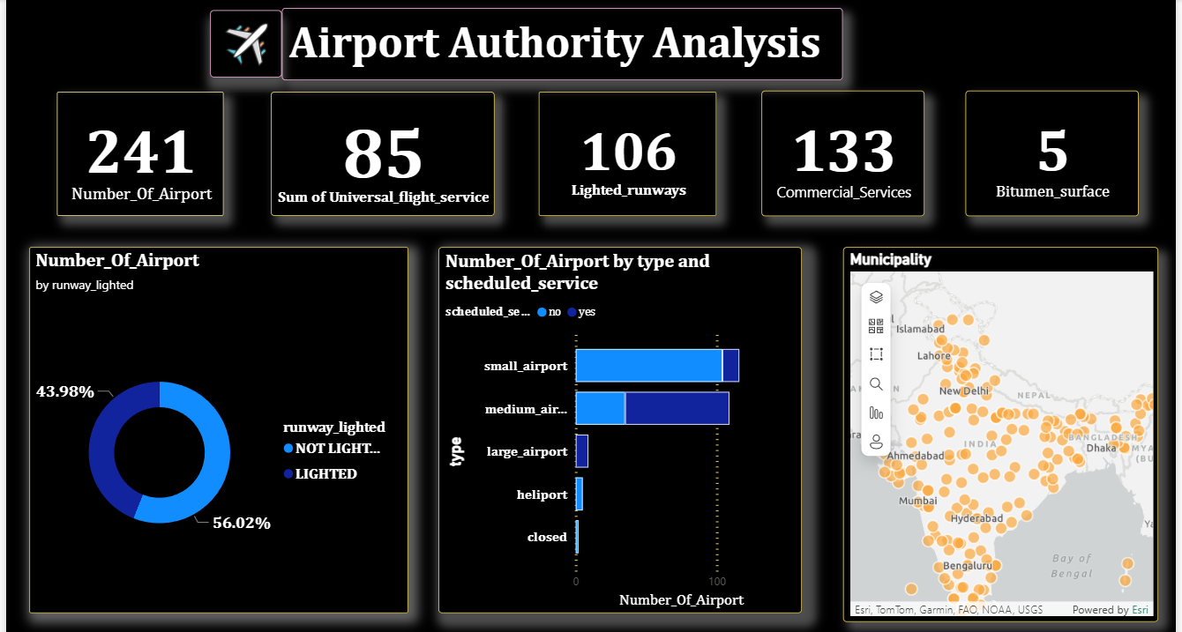

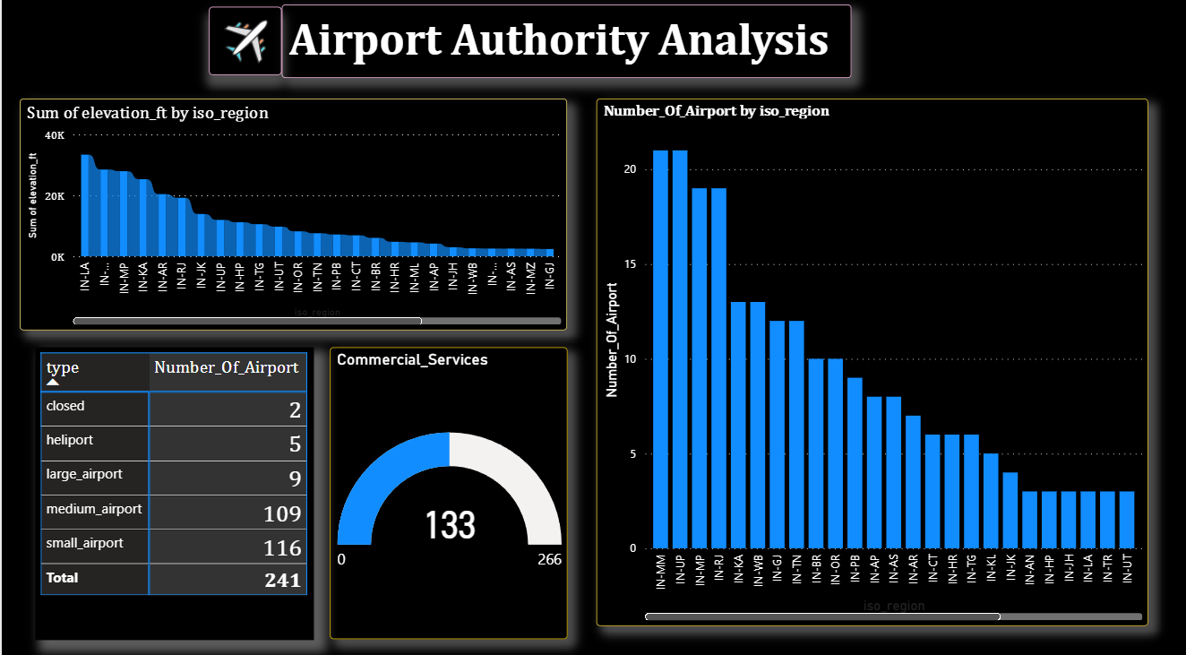

12. Challenges Faced

Multiple challenges emerged throughout the project lifecycle. The first major challenge was data quality issues, including missing fields, inconsistent values, and duplicates across datasets. This required significant manual and automated cleaning efforts. The second challenge involved integrating data from diverse sources, each with different formats and schema structures. Additionally, some data lacked clear documentation, requiring assumptions and validation through exploratory analysis. Performance challenges arose when loading large datasets into Power BI, necessitating optimization techniques such as aggregations and incremental refresh. Finally, ensuring the dashboard remained user-friendly while displaying complex operational metrics required careful design and visualization choices.

13. Solutions Implemented

To address data quality problems, robust cleaning procedures were implemented, including validation rules, normalization of categorical variables, and removal of unusable records. For integration issues, SQL scripts and Python routines were used to standardize data structures before loading into Power BI. Performance problems were mitigated by optimizing data models, introducing query folding, and reducing column cardinality. To enhance the dashboard’s usability, a streamlined layout was created using consistent color schemes, icons, and logical grouping of KPIs. These solutions ensured that the final system was both efficient and user-friendly, capable of handling complex datasets without compromising performance.

14. Conclusion

The Airport Authority Analysis project successfully demonstrated how Power BI can transform large volumes of raw operational data into meaningful insights that support improved decision-making. The dashboard created through this project provides airport administrators with real-time visibility into critical performance metrics, enabling proactive responses to operational challenges. Through advanced data modelling and visualization, the project highlighted opportunities for enhancing efficiency, reducing delays, improving resource allocation, and elevating the overall passenger experience. The findings underscore the importance of adopting modern BI tools within transportation sectors, particularly airports where data complexity and volume continue to grow. This project serves as a foundation for future analytical advancements within the Airport Authority.

15. Future Enhancements

The potential for future improvements is extensive. Integrating real-time data feeds such as live flight status, weather updates, and passenger flow sensors would significantly enhance the dashboard’s operational value. Incorporating predictive analytics could enable forecasting of flight delays, resource shortages, and peak traffic times, while integrating machine learning models could improve accuracy in predictions. Additional enhancements include expanding the dashboard to support airport security, baggage handling analytics, and environmental monitoring. Cloud integration with Azure or AWS could improve scalability and introduce automation. These enhancements would transform the current dashboard into a full-scale intelligent airport operations platform.

16. References

References include academic research papers on airport operations, official aviation standards, public airport performance datasets, Power BI documentation, SQL database manuals, and online tutorials on BI dashboard development. Additional references include industry whitepapers on aviation trends, articles on passenger flow optimization, and technology blogs related to data visualization and ETL processes.
Microsoft Power Bi official documentation.

17. Appendix

The appendix section provides supplementary materials including raw data samples, data dictionaries, schema diagrams, and additional charts that support the main analysis. It includes before-and-after snapshots of data cleaning steps, SQL extraction queries, Python preprocessing scripts, and extended visualizations that were not included in the dashboard. These supporting documents offer deeper insights into the technical processes behind the project and act as valuable references for further development.

